Fitness Component | Exercise/ Pose/ Position | Picture
Flexibility | Side Stretch  Hold for 5 to 10 seconds. | 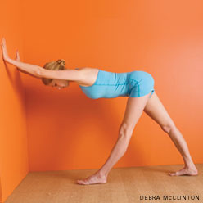
Flexibility | Child's Pose  Hold for 5 to 10 seconds. | 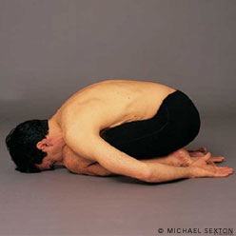
Muscular  Endurance | Push-up Hockey  Try to hold the push-up position as long as you can without resting. Play 1 or 2 games to 5 points. | Try to score by sliding a beanbag in between your opponent’s arms while in the push-up position.
Muscular  Strength | Push-ups  Try to do as many as possible. | 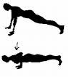
Cardiovascular/  Aerobic Endurance | Line jumps  Jump until you get tired, time yourself and try to jump longer next time. | Jump back and forth over a line. Side to side or front to back, you can crisscross your legs while jumping. Be creative.

